Exercise for week 1:

Ches Deul 1158163

What you found

- Simple text: Zuyd
- Double happiness: 囍
- Pile of Poo: 💩
- BONUS: My first name is somewhere in the file as well, using Base64-encoding!

Where you found it (locations)

Simple text: Zuyd
UTF-8 code units: 5A 75 79 64
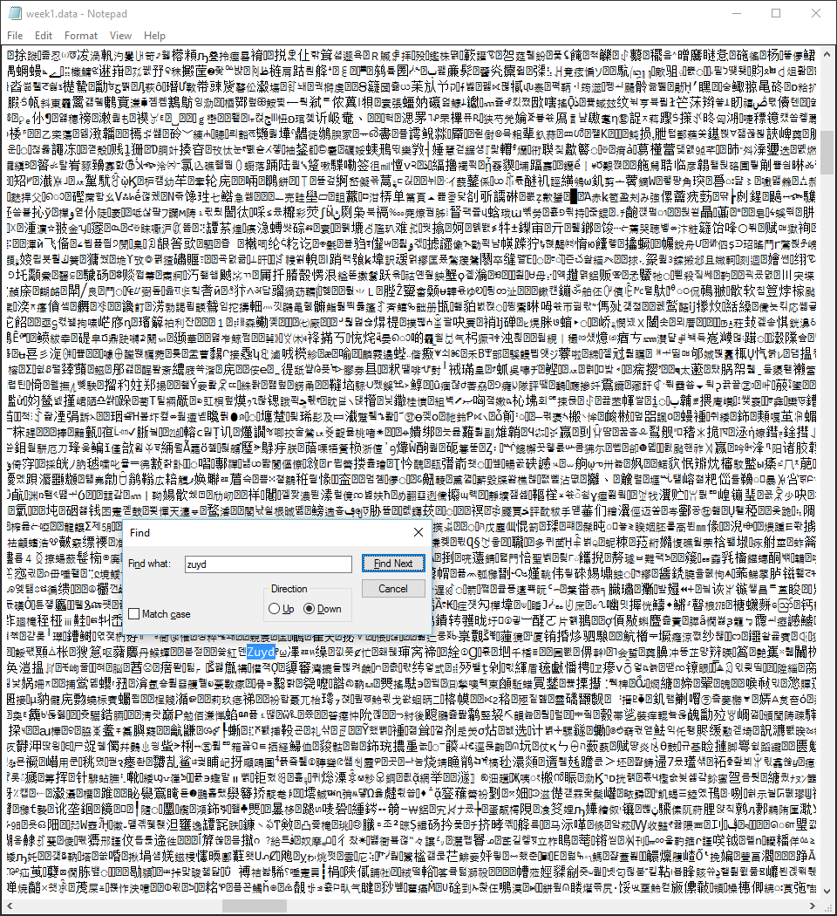

Double happiness: 囍
7 keer gevonden
UTF-8 code units: E5 9B 8D
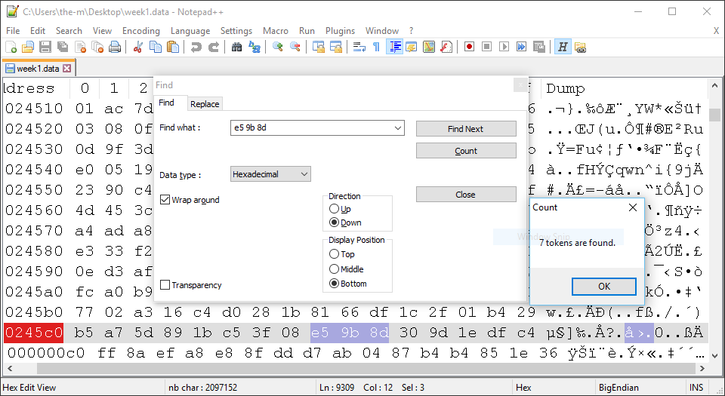

Pile of Poo: 💩
7 keer gevonden
UTF-8 code units: F0 9F 92 A9
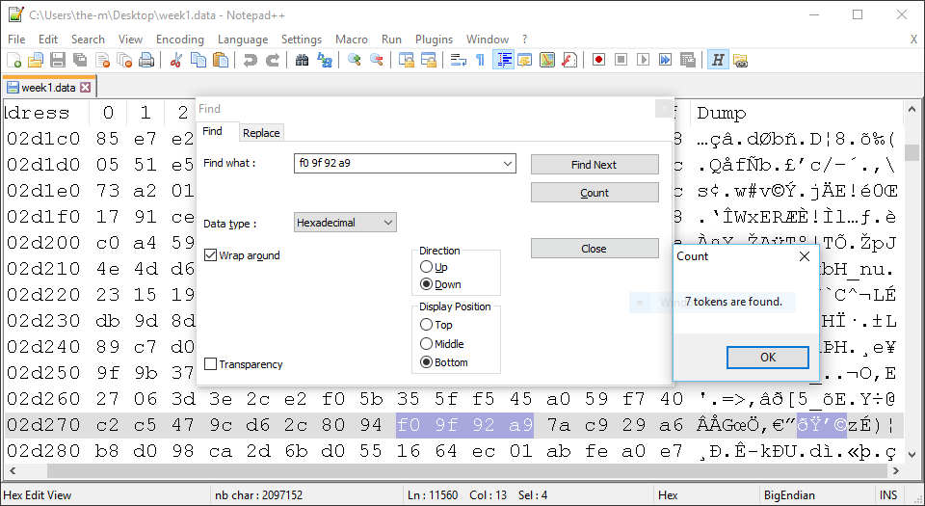

How you found it. What tools? Include source, screenshots, howto's, etc.

Gebruikte middelen:
https://r12a.github.io/apps/conversion/
Notepad++

Put the report in the /exercises/week1/yourgroupname directory in the repo and
send it in as a Pull Request on Github.

Good luck!

